DATA STRUCTURES LAB EXPERIMENTS

SANSKRUTI SAMANT

USN: 2GI17EC113

DIV: B

# **EXPERIMENT 3 b:** Fibonacci Sequence Using Recursion in C++..

* **PROBLEM STATEMENT**:

Write C++ program to generate Fibonacci sequence using recursion.

* **ALGORITHM:**

1. Read the number of terms in the Fibonacci sequence from user.
2. Starting from 0 till the number of terms minus 1 call the function fib() which calculates the Fibonacci of the number and display the Fibonacci of that number.
3. In fib function,
4. If the number is 0 or 1 return the number as it is.
5. If number is other than 0 or 1 then call the fib() function recursively as per the equation

fibterm=fib(n-1)+fib(n-2)

1. Return the fibterm.

* **PROGRAM CODE:**

//TO GENERATE FIBONACCI SEQUENCE USING RECURSION

#include<iostream>

using namespace std;

int fib(int n)

{ //cout<<"{"<<n<<"}\t";

int fibTerm;

if((n==1)|(n==0))

fibTerm=n;

else

fibTerm = (fib(n-1)+fib(n-2));

return fibTerm;

}

int main()

{

int n,i=0;

cout<<"Input the number of terms for Fibonacci series:",cin>>n;

cout<<"\n Fibonacci series is as follows\n";

while(i<n)

{

cout<<" "<<fib(i)<<endl;

i++;

}

return 0;

}

* **PROGRAM OUTPUT:**

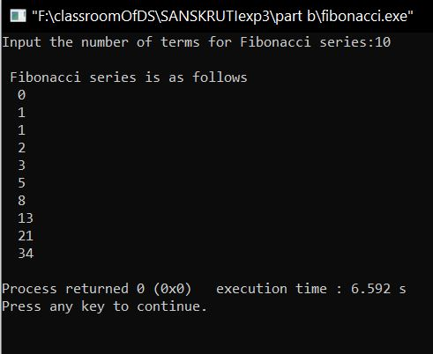

* **ANALYSIS (LIMITATIONS):**

There are following limitations of above implementation.

Time Complexity:

We can observe that this implementation does a lot of repeated work. So this is a bad implementation for nth Fibonacci number.